**QR CODE BASED BILLING SYSTEM FOR SHOPS USING ANDROID SMART PHONES**

**A PROJECT REPORT**

*Submitted by*

**NALENDRAN.M (50810205038)**

**PRASHANTH.M (50810205047)**

**SENTHIL KUMAR.P (50810205060)**

**SURESH.J (50810205068)**

*In partial fulfilment for the award of the degree*

*of*

**BACHELOR OF TECHNOLOGY**

*in*

**INFORMATION TECHNOLOGY**

**ARUNAI COLLEGE OF ENGINEERING**

**TIRUVANNAMALAI::606 603**

(Accredited by the National Board of Accrediation)

(An ISO 9001:2008 Certified Institution)



**ANNA UNIVERSITY:: CHENNAI 600 025**

**APRIL 2014**

**ANNA UNIVERSITY: CHENNAI 600 025**

**BONAFIDE CERTIFICATE**

Certifide that this project report ”**QR CODE BASED BILLING SYSTEM FOR SHOPS USING ANDROID SMARTPHONES**” is the bonafide work of **NALENDRAN.M (50810205038), SENTHILKUMAR.P (50810205060), PRASHANTH.M (50810205047), SURESH.J (50810205068)** who carried out the project work under my supervision.

**SIGNATURE SIGNATURE**

**Mr.N.ANANDA KUMAR ,M.E., Mr.R.MANIKANDAN, M.E.,**

Asso Prof/IT, Asst Prof/IT,

**HEAD OF THE DEPARTMENT, SUPERVISOR,**

Dept of Information Technology, Dept of Information Technology,

Arunai College of Engineering, Arunai College of Engineering,

Velu Nagar, Mathur, Velu Nagar, Mathur,

Tiruvannamalai- 606 603. Tiruvannamalai- 606 603.

Submitted for VIVA-VOCE held on………………….at Arunai College of Enginnering, Tiruvannamalai.

**INTERNAL EXAMINER EXTERNAL EXAMINER**

**ACKNOWLEDGEMENT**

We are extremely thankful to our Management for having included us to annex the golden opportunity of studying this course in this college. We wish to thank our Chairman **Mr.E.V.Velu, M.A., M.L.A.,** Vice Chairman **Mr.E.V.Kumaran, M.E.,** and Managing Director **Dr.E.V.Kamban, M.D.,** for their innovative suggestion and encouragement.

We wish to thank our Secretary **Mr.R.Selvaraj** and Principal **Dr.Thandapani, Ph.D.,** for being a source of inspiration. We extend our heartfelt and genuine gratitude to our Dean **Dr.S.Selvakumar Raja, Ph.D.,** and our Head of Department **Mr.N.Ananda Kumar, M.E.,**  and Guide **Mr.R.Manikandan, M.E.,** for their valuable suggestion throughout this project.

We express our heartiest gratitude to all faculty members of **IT Department** and other Staff of our college for providing their valuable suggestion at different stage of the project.

Finally, We express our thanks to our **Parents** and **Friends** for their prayers, enthusiasm and endless support without which this project wouldn’t have been completed.

**TABLE OF CONTENTS**

**CHAPTER NO TITLE PAGE NO**

**ABSTRACT** i

**LIST OF FIGURES** ii

**LIST OF ABBREVIATIONS** iii

**1 INTRODUCTION** 1

**2 LITERATURE SURVEY** 3

**3 SYSTEM ANALYSIS** 6

3.1EXISTING SYSTEM 6

3.2PROPOSED SYSTEM 7

**4 SYSTEM REQUIREMENTS** 8

4.1 REQUIREMENTSPECIFICATIONS8

4.1.1SOFTWARE REQUIREMENTS 8

4.1.2HARDWARE REQUIREMENTS 8

**5 SYSTEM DESIGN** 9

5.1 DATA FLOW DIAGRAM9

5.2 USE CASE DIAGRAM10

5.3 SEQUENCE DIAGRAM11

5.4 COLLABORATION DIAGRAM12

5.5 ACTIVITY DIAGRAM13

5.6 CLASS DIAGRAM14

**6 SYSTEM IMPLEMENTATION** 15

6.1 SYSTEM ARCHITECHTURE 15

6.2 MODULES 16

6.3 MODULE DESCRIPTION16

6.3.1GENERATING QR CODE IMAGE 16

6.3.2MOBILE AUTHENTICATION 16

6.3.3QR CODE SCANNER MODULE 17

6.3.4WEB SERVICE CLIENT MODULE 17

**7 SOFTWARE TESTING** 18

7.1 TESTING OBJECTIVES 18

7.2 TEST CASE DESIGN19

7.2.1UNIT TESTING 19

7.2.2INTEGRATION TESTING 20

7.2.3VALIDATION TESTING 20

**7.3 TESTING STRATEGIES** 20

7.3.1INTEGRATION TESTING 21

7.3.2WHITE BOX TESTING 21

7.3.3BLACK BOX TESTING 21

7.3.4INTERFACE TESTING 21

7.3.5MODULE TESTING 22

7.3.6SMOKE TESTING 22

**8 CONCLUSION** 24

**9 FUTURE ENHANCEMENT** 25

**10 APPENDICES** 26

10.1 APPENDIX1-

SOFTWARE DESCRIPTION26

10.2 APPENDIX2-SAMPLE CODING28

10.3 APPENDIX3-SCREEN SHOTS38

**11 REFERENCES** 46

**ABSTRACT**

Augmented reality is a technology that involves digital content deployed in the physical world in real time through the use of devices and sensors that allow users to interact with the resulting hybrid environment. Likewise, QR codes have become popular and accepted by the general public. They are useful for conveying information in the physical world and thus connect to the digital world in a practical and simple way. This project presents an application of QR codes for generating augmented reality environments. Using the notion of contexts, a complete user interaction is enabled in terms of the relationship of QR codes and augmented reality. We present an analysis of augmented reality technologies supported by this approach as well as the architecture and operation of a system that implements these concepts.

i

**LIST OF FIGURES**

**FIGURE NO NAME OF THE FIGURES PAGE NO**

**5.1 DATAFLOW DIAGRAM** 9

**5.2 USE-CASE DIAGRAM** 10

**5.3 SEQUENCE DIAGRAM**  11

**5.4 COLLABORATION DIAGRAM** 12

**5.5 ACTIVITY DIAGRAM** 13

**5.6 CLASS DIAGRAM** 14

**6.1 SYSTEM ARCHITECTURE** 15

ii

**LIST OF ABBREVIATIONS**

**S.NO ACRONYMS ABBREVIATIONS**

1. QR Quick Response

2. AR Augmented Reality

3. MVC Model View controller

iii

**INTRODUCTION**

**CHAPTER 1**

**INTRODUCTION**

QR code is the trademark for a type of [matrix barcode](/wiki/Matrix_barcode) first designed for the [automotive industry in Japan](/wiki/Automotive_industry_in_Japan). A barcode is a machine-readable optical label that contains information about the item to which it is attached. A QR code uses four standardized encoding modes to efficiently store data & extensions may also be used. The QR Code system has become popular outside the automotive industry due to its fast readability and greater storage capacity.Applications include product tracking, item identification, time tracking, document management, general marketing, and much more.A QR code consists of black modules arranged in a square grid on a white background, which can be read by an imaging device and processed using error correction until image can be appropriately interpreted; data is then extracted from patterns present in both horizontal and vertical components of the image. During recent years, there are major developments in the adoption of 2D Codes such as:

a)The directive by International Air Transport Association (IATA) for airports worldwide to adopt 2D bar code for passenger boarding passes by 2010.

b)The adoption of QR Code for patient identification by two leading hospitals in Singapore and all hospitals in Hong Kong.

c) The use of 2D bar codes/micro codes for various applications in the other sectors.

d) The use of QR code with mobile phones in Japan and Korea. Examples of such applications are:

1

• Large scale QR Codes on buildings to enable users to use mobile phone to scan the QR Code to retrieve information about the companies that are operating inside the buildings.

• The use of mobile phone to scan the QR Code on the packaging of fruits or vegetables to retrieve information about the name of the farm from which the fruits and vegetables are grown and harvested; also the

fertilisers and insecticide used. The QR Codes on the food packages when scanned will also enable consumers to download information on cooking recipes.

• QR Codes for location based services on maps in the Tokyo subway and central bus stations. Passengers can use their mobile phones to scan the QR Code to find out the arrival time of the next bus.

• ePayment using mobile phone and QR Code printed on the bills.

2

**LITERATURE SURVEY**

**CHAPTER-2**

**LITERATURE SURVEY**

**1. “Use Multiplexing to Increase Information in QR Code**”**( Antonio Grillo_, Alessandro Lentini)**

This technique can increase the amount of data, as the original information, in QR Code as well as keeping secret information. The original data for encoding is divided into smaller parts, each part will form QR Code pattern in its standard form. Each pattern is encoded or multiplexed and represented each module in QR Code with black and white special symbols. At the receiving end, this QR Code with special symbols is decoded to give back the number of QR Code patterns that was multiplexed. These QR Code pattern can be read by the general QR Code reader and the data can be concatenated back to form its original information.

**2. “A new Method of QR Code Accumulation Encoding in Mobile Education”(** **Suppat Rungraungsilp, Mahasak Ketcham)**

QR code identification is a kind of effective method in mobile education information authentication, this paper puts forward a new QR code accumulation encoding method owing to the limited information faults in traditional QR code encoding. The accumulation of segmentation and bar code decoding identification were improved in this method. Through experiment analysis and compared with the original QR code encoding, it can be concluded that the method in encoding output, image segmentation and decoding aspects has better effects for large capacity files.

3

**3. “Identifying QR Code” By Comparing the images (Chanon Skawattananon, Mahasak Ketcham)**

Bit error rate or BER is the basic idea of comparison between two pictures to perform the number of bit errors divided by the total number of transferred bits during a studied time interval. In image processing, we use to compare two images in order that measure quality of them. In this paper propose method by use adaptation of brightness in image to get lower BER. We focus on QR Code image compare with QR Code is overlapped by a portrait and test by decode them. In our approach we implement to build Identifying QR Code.

**4. “A Technique to Remove Scratches from QR Code Images” (Kamon Homkajorn, Mahasak Ketcham)**

Based on this article in this research paper, our study introduces an advance technique on removing scratch or damage that exists on QR-code.The QR-code decoding algorithm is unable to decode if the scratch that applies on the QR code is more than Error Correcting Level threshold of current QR-code or the damage applies on some curtain area, which consider as information area of the QRcode.The scratch removal technique consists of several processes. In order to extract scratch from damage QR-code, simulate HSV is apply and scratch on damage QR-code become more distinctive.

4

**5. “A Simple and Efficient Image Pre-processing for QR Decoder” (Weibing Chen, Gaobo Yang).**

In order to lower the consumed threshold, a practical image preprocessing method was proposed for Quick Response barcode recognition. It could increase the speed of recognition by this decoder so as to embed this algorithm into mobile terminals. Instead of using the traditional methods such as edge detection and line detection, the encoding characteristic of QR had been used, thus the influence by background noise and geometric distortion was minimized. Moreover, it used alignment patterns to adaptively sample the barcode in terms of regions, which greatly improved the recognition rate. Experimental results demonstrate that the proposed approach can overcome the influence in noise, inhomogeneous light and geometric distortion, what is more, it meets the requirement of decoding in real time.

5

**SYSTEM ANALYSIS**

**CHAPTER – 3**

**SYSTEM ANALYSIS**

**3.1 EXISTING SYSTEM**

* Barcodes are often intended for consumer use where using a barcode device, a consumer can take an image of a barcode on a product.
* The barcode must be read using computer vision techniques and barcode can hold information, it makes this vision task in consumer scenarios unusually challenging.
* Barcode decoder can give the vision algorithm feedback, and develop a progressive strategy of the product.

**DISADVANTAGES**

* System software failure may cost more delays and a light beam might be refracted by water particles suspended in the atmosphere, resulting in focus distortion.
* In laser scanning, durability and cost are the two disadvantages and a barcode becomes scratched or crumpled the reader may not be able to read it.
* If the scan rate of a reader is exceeded by the speed of movement of the bar codes, a loss of reading accuracy, together with failure to read a bar code
* A bar code reader cannot read a bar code if there is any obstacle

6

**3.**2 **PROPOSED SYSTEM**

* In the proposed system, we are using Multiplexing and Demultiplexing algorithm for recognizes QR code image using smart phones to provide various services that can recognize the authenticity of any product.
* So QR code verifies products by capturing it through the smart phone, then decodes and sends it to the server for authentication.
* The customer forwards the selected product list to the server that enables the consumer to decide based on the products authenticity.

**ADVANTAGES**

* A simple scan captures the desired information.
* The Decoded data can be stored in the server and can be viewed by the cashier.
* High accuracy in image capturing
* Customer can easily detect the qr code image, via his Android mobile itself.

7

**SYSTEM REQUREMENTS**

**CHAPTER 4**

**4.1 SYSTEM REQUIREMENTS SPECIFICATION**

The purpose of the Software Requirement Specification is to produce the specification of the analysis task and also to establish complete information about the requirement, behavior and other constraints such as functional performance and so on. The goal of Software Requirement Specification is to completely specify the technical requirements for the software product in a concise and unambiguous manner.

**4.1.1Software Requirements:**

* Operating system : Windows XP
* Technology Used : Android 2.2
* IDE : Eclipse 3.4 (min)
* Emulators : Micro emulator 5055
* Plug-in : ADT plug-in
* Tools used : Android SDK1.2

**4.1.2Hardware Requirements:**

* Processor : Pentium P4
* Motherboard : Genuine Intel
* RAM : Min 1 GB
* Hard Disk : 80 GB

8

**SYSTEM DESIGN**

**CHAPTER 5**

**SYSTEM DESIGN**

**5.1 DATAFLOW DIAGRAM:**

A data flow diagram (DFD) is a graphical representation of the "flow" of data through an [information system](http://en.wikipedia.org/wiki/Information_system), modeling itsprocess aspects.

Fig.5.1 Dataflow Diagram

9

**5.2 USECASE DIAGRAM**

A use case diagram at its simplest is a representation of a user's interaction with the system and depicting the specifications of a [use case](http://en.wikipedia.org/wiki/Use_Case).



Fig 5.2 Use case Diagram

10

**5.3 SEQUENCE DIAGRAM**

A sequence diagram is an [interaction diagram](http://en.wikipedia.org/wiki/Interaction_diagram) that shows how processes operate with one another and in what order. It is a construct of a [Message Sequence Chart](http://en.wikipedia.org/wiki/Message_Sequence_Chart).

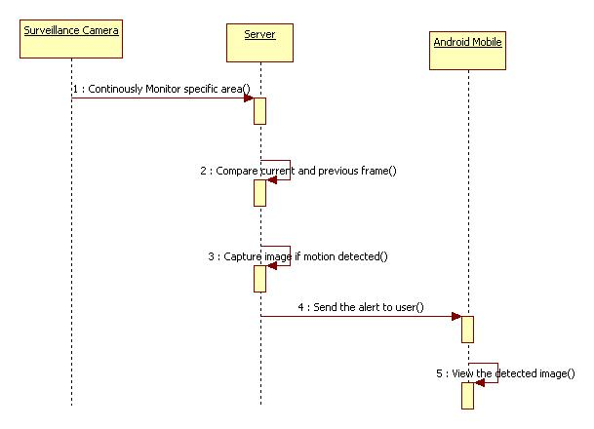

Fig 5.3 Sequence Diagram

11

**5.4 COLLABORATION DIAGRAM**

A Communication diagram models the interactions between objects or parts in terms of sequenced messages. Communication diagrams represent a combination of information taken from [Class](http://en.wikipedia.org/wiki/Class_diagram), [Sequence](http://en.wikipedia.org/wiki/Sequence_diagram), and [Use Case Diagrams](http://en.wikipedia.org/wiki/Use_case_diagram) describing both the static structure and dynamic behavior of a system.

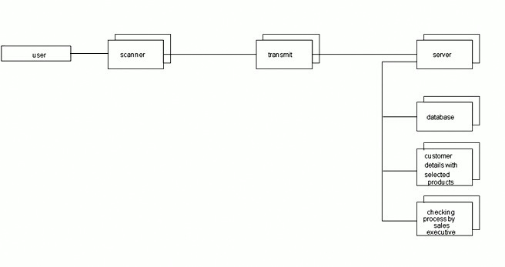

Fig 5.4 Collaboration Diagram

12

**5.5 ACTIVITY DIAGRAM**

Activity diagrams are graphical representations of [workflows](http://en.wikipedia.org/wiki/Workflow) of stepwise activities and actions with support for choice, iteration and concurrency.



Fig 5.5 Activity Diagram

13

**5.6 CLASS DIAGRAM**:

In [software engineering](http://en.wikipedia.org/wiki/Software_engineering), a class diagram in the [Unified Modeling Language](http://en.wikipedia.org/wiki/Unified_Modeling_Language) (UML) is a type of static structure diagram that describes the structure of a system by showing the system's [classes](http://en.wikipedia.org/wiki/Class_(computer_science)), their attributes, operations (or methods), and the relationships among objects.



Fig 5.6 Class Diagram

14

**SYSTEM IMPLEMENTATION**

**CHAPTER 6**

**SYSTEM IMPLEMENTATION**

**6.1 SYSTEM ARCHITECTURE**

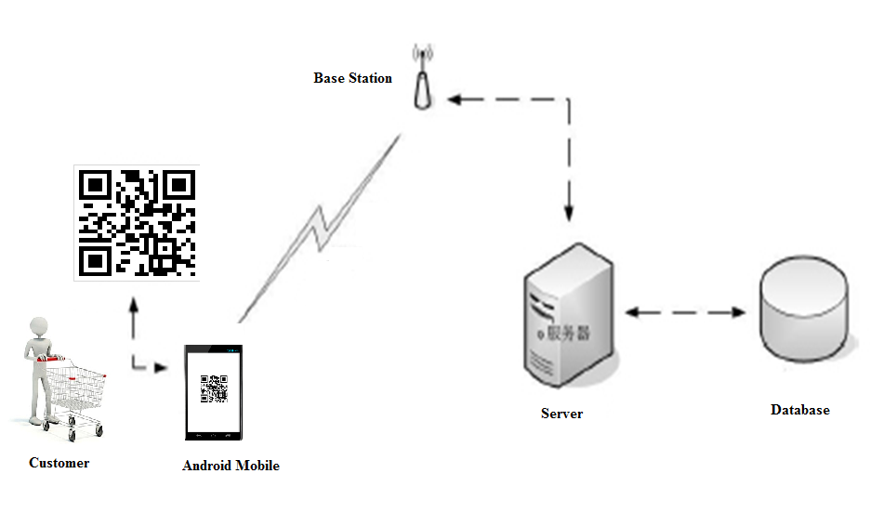

Fig 6.1System Architechture

15

**6.2 MODULES**

* Generating QR code image
* Mobile Authentication Module
* QR Code Scanner Module
* Web service client module

**6.3 MODULE DESCRIPTION**

**6.3.1 Generating QR code image**

* In this module we are creating qr code for encoding the information about the products. The product contains name, code, quantity and price. Each pattern is encoded and represented each module in qr code with black and white special symbols.
* Qr code can hold information more than other bar codes. The format of QR Code includes unique Finder Pattern (Position Detection Patterns) located at three corners of the symbol and can be used to locate the positioning of the symbol, size and inclination.

**6.3.2 Mobile Authentication Module**

* This module represents the authentication, which is used for the customer to login their details for the shopping processes.
* Authentication is used as the basis or authorization determining whether a privilege will be granted to a particular user or process. The validation process are done on the webserver.

16

**6.3.3 QR Code Scanner Module**

* This module is used to scan the QR code and read the value of the QR code inside the mobile. QR code is a matrix bar code designed to be read by Smartphone.
* The code contains of black modules arranged in a square pattern on a white background. The information encoded may be text, a URL, or other data. If the user selects the product, the details will directly forward to the server.

**6.3.4 Web service client module**

* This module has the process of storing the selected product’s information from the client, which are send through the web service. All these informations will be stored in the database.
* We are maintaining a centralized server in order to receive the selected product list from the customer through internet.
* In this module the merchant see the ordered items from the client. The Merchant will use this list to do delivery the items to the customers.

17

**SOFTWARE TESTING**

**CHAPTER 7**

**SOFTWARE TESTING**

**7.1 TESTING OBJECTIVES**

Testing is a set of activities that can be planned in advance and conducted systematically. For this reason a template for software testing, a set of steps into which we can place specific test case design techniques and testing methods should be defined for software process. Testing often accounts for more effort than any other software engineering activity. If it is conducted haphazardly, time is wasted, unnecessary effort is expanded, and even worse, errors sneak through undetected. It would therefore seem reasonable to establish a systematic strategy for testing software.

**Type of Testing**

There are two type of testing according their behaviours

1. Unconventional Testing

2. Conventional Testing

**Unconventional Testing**

Unconventional testing is a process of verification which is doing by SQA (Software Quality Assurance) team. It is a prevention technique which is performing from begging to ending of the project development. In this process SQA team verifies project development activities and insuring that developing project is fulfilling the requirement of the client or not. The method follows:

18

1. Peer review

2. Code walk and throw

3. Inspection

4. Document Verification

**Conventional Testing**

Conventional Testing is a process of finding the bugs and validating the project. Testing team involves in this testing process and validating that developed project is according to client requirement or not. This process is a correction technique where testing team find bugs and reporting to the development team for correction on developed project built.

**7.2 TEST CASE DESIGN**

**7.2.1 Unit Testing**

The primary goal of unit testing is to take the smallest piece of testable software in the application, isolate it from the remainder of the code, and determine whether it behaves exactly as you expect. Each unit is tested separately before integrating them into modules to test the interfaces between modules. Unit testing has proven its value in that a large percentage of defects are identified during its use. In the company as well as seeker registration form, the zero length username and password are given and checked. Also the duplicate username is given and checked. The dates are entered in wrong manner and checked. Wrong email-id and web site URL is given and checked.The unit Testing is successfully tested.

19

**7.2.2 Integration Testing**

Testing is done for each module. After testing all the modules, the modules are integrated and testing of the final system is done with the test data, specially designed to show that the system will operate successfully in all its aspects conditions. Thus the system testing is a confirmation that all is correct and an opportunity to show the user that the system works.The Integration Testing is successfully tested.

**7.2.3 Validation Testing**

The final step involves Validation testing, which determines whether the software function as the user expected. The end-user rather than the system developer conduct this test most software developers as a process called “Alpha and Beta Testing” to uncover that only the end user seems able to find. The compilation of the entire project is based on the full satisfaction of the end users. In the project, validation testing is made in various forms. In question entry form, the correct answer only will be accepted in the answer box. The answers other than the four given choices will not be accepted.The Validation testing is successfully tested.

**7.3 TESTING STRATEGIES**

A number of software testing strategies have been proposed in the literature. All provide the software developer with a template for testing and all have the following generic characteristics:

1. Testing begins at the component level and works “outward” toward the integration of the entire computer-based system.
2. The developer of the s/w conducts testing and for large projects, independent test group.

20

**7.3.1 Integration Testing**

The strategies for integrating software components into a functioning product include the bottom-up strategy, the top-down strategy and to ensure that modules will be available for integration into the evolving software product when needed. The integration strategy dictates the order in which modules must be available and thus exerts a strong influence on the order in which modules are written, and debugged.The Integation testing is successfully tested.

**7.3.2 White Box Testing**

It is just the vice versa of the Black Box testing. There we do not watch the internal variables during testing. This gives clear idea about what is going on during execution of the system. The point at which the bug occurs were all clear and were removed.The White Box testing is successfully tested.

**7.3.3 Black Box Testing:**

In this testing we give input to the system and test the output. Here we do not go for watching the internal file in the system and what are the changes made on them for the required output.The black box testing is successfully tested.

**7.3.4 Interface Testing**

The Interface Testing is performed to verify the interfaces between sub modules while performing integration of sub modules aiding master module recursively.The interface testing is successfully tested.

21

**7.3.5 Module Testing**

Module Testing is a process of testing the system, module by module. It includes the various inputs given, outputs produced and their correctness. By testing in this method we would be very clear of all the bugs that have occurred.The module testing is successfully tested.

**7.3.6 Smoke testing**

Smoke testing refers to physical tests made to closed systems of pipes to test for leaks. By metaphorical extension, the term is also used for the first test made after assembly or repairs to a system, to provide some assurance that the system under test will not catastrophically fail. After a smoke test proves that "the pipes will not leak, the circuit will not burn, or the software will not crash outright”,] the system is ready for more stressful testing.The term smoke testing is used in several fields,including [electronics](http://en.wikipedia.org/wiki/Electronics),  [computer](http://en.wikipedia.org/wiki/Computer_software) software  development,  [plumbing](http://en.wikipedia.org/wiki/Plumbing),  [woodwind](http://en.wikipedia.org/wiki/Woodwind)  repair,  [infectious disease](http://en.wikipedia.org/wiki/Infectious_disease) control,and the  [entertainment industry](http://en.wikipedia.org/wiki/Entertainment_industry).The smoke testing is successfully testing.

**Maintenance**

The objectives of this maintenance work are to make sure that the system gets into work all time without any bug. Provision must be for environmental changes it may affect the computer or software system. This is called the maintenance of the system. Nowadays there is the rapid change in the software world. Due to this change, the system should be capable of adapting these changes. In our project the process can be added without affecting other parts of the system. Maintenance plays a vital role. The system will able to accept any modification after its implementation.

22

This is the final step in system life cycle. Here we implement the tested error-free system into real-life environment and make necessary changes, which runs in an online fashion.

As a rule, system testing takes, as its input, all of the "integrated" software components that have successfully passed [integration testing](http://en.wikipedia.org/wiki/Integration_testing) and also the software system itself integrated with any applicable hardware system. The purpose of integration testing is to detect any inconsistencies between the software units that are integrated together or between any of the assemblages and the hardware. System testing is a more limited type of testing; it seeks to detect defects both within the "inter-assemblages" and also within the system as a whole.

23

**CONCLUSION**

**CHAPTER 8**

**CONCLUSION**

* According to this project we proposed a real time capturing system for customer supplies using Quick Response (QR) code in Android smartphone.
* QR code verifies products by capturing it through the smart phone, then decodes and sends it to the server for authentication.
* The customer forwards the selected product list to the server and the response received from the server enables the consumer to decide based on the products authenticity.
* An interesting future study might involve to simulate payment method at different gateway.

24

**FUTURE ENHANCEMENT**

**CHAPTER 9**

**FUTURE ENHANCEMENT**

Though this project has many added advantage, in future we like to upgrade this into the next level that is not only by just viewing the QR code in the Shoping web sites, we can also view the entire clip of what happened and what has been captured. All this will be done just at the spontaneous moment, within seconds of the action been happened at the site.

25

**APPENDICES**

**CHAPTER 10**

**APPENDICES**

**SYSTEM DESCRIPTION**

This project can be implemented only in JAVA because Android supports only JAVA for user applications.

**JAVA**

Java is Platform Independent. Java is an object-oriented programming language developed initially by James Gosling and colleagues at Sun Microsystems. It implements a strong security model, which prevents compiled Java programs from illicitly accessing resources on the system where they execute or on the network. Popular World-Wide Web browsers, as well as some World-Wide Web servers and other systems implement Java interpreters. These are used to display interactive user interfaces, and to script behaviour on these systems.

**Android**

Android is a complete set of software for mobile devices such as tablet computers, smart phones, electronic book readers, notebooks, set-top boxes etc. It contains an linux-based OS, middleware and key mobile applications.It can be thought of as a mobile operating system. But it is not limited to mobile only. It is currently used in mobiles, tablets, televisions etc.

26

**XML**

XML is a markup language for documents containing structured information. Structured information contains both content and some indication of what role that content plays. Almost all documents have some structure. A markup language is a mechanism to identify structures in a document. The XML specification defines a standard way to add markup to documents.

**MYSQL SERVER**

Microsoft SQL Server is an application used to create computer databases for the Microsoft Windows family of server operating systems. Microsoft SQL Server provides an environment used to generate databases that can be accessed from workstations, the Internet, or other media such as a personal digital assistant. MySQL is a popular choice of database for use in web applications, and is a central component of the widely used LAMP open source web application software stack—LAMP is an acronym for " Linux, Apache, MySQL, Perl/PHP/Python". MySQL works on many different system platforms, including AIX, BSDi, FreeBSD, HP-UX, eComStation, i5/OS, IRIX, Linux, Mac OS X, Microsoft Windows, NetBSD, Novell NetWare, OpenBSD, OpenSolaris, OS/2 Warp, QNX, Solaris, Symbian, SunOS, SCO OpenServer, SCO UnixWare, Sanos and Tru64. A port of MySQL to OpenVMS also exists.

MySQL is primarily an RDBMS and ships with no GUI tools to administer MySQL databases or manage data contained within the databases. Users may use the included command line tools, or download MySQL front-ends from various parties that have developed desktop software and web applications to manage MySQL databases& build database structures.27

**APPENDICES**

**SAMPLE CODING**

**CONNECTION MANAGER.JAVA**

It is used to connect user to server and manage the user account details.

package com.uniq;

import java.sql.Connection;

import java.sql.SQLException;

public class ConnectionManager {

static Connection conn = null;

static String url = "jdbc:mysql://localhost:3306/qrcode";

public static Connection getConnection() {

try { Class.forName("com.mysql.jdbc.Driver");

String username = "root";

String password = "root";

conn = DriverManager.getConnection(url, username,password);

} catch (ClassNotFoundException e) {

e.printStackTrace();

} catch (SQLException e) {

e.printStackTrace(); }return conn; }}

28

**LOGIN CHECKER.JAVA**

It is used to verify the user and merchant account weather valid or not.

package com.uniq;

import java.io.IOException;

import javax.servlet.http.HttpServletRequest;

import javax.servlet.http.HttpServletResponse;

public class LoginChecker extends HttpServlet {

Connection con;

Statement st;

ResultSet rs;

protected void processRequest(HttpServletRequest request,

HttpServletResponse response) throws ServletException, IOException,

SQLException {

response.setContentType("text/html;charset=UTF-8");

PrintWriter out = response.getWriter();

try { String user = request.getParameter("user");

String pass = request.getParameter("pass");

String url = "jdbc:mysql://localhost:3306/qrcode";

Class.forName("com.mysql.jdbc.Driver");

29

con = DriverManager.getConnection(url, "root", "root");

st = con.createStatement();

rs = st.executeQuery("select * from userlogin");

boolean flag = false;

while (rs.next()) {

String dbuser = rs.getString(1);

String dbpass = rs.getString(2);

if (user.equalsIgnoreCase(dbuser) && pass.equals(dbpass)) {

flag = true;

break;

}}

if (flag) {

response.sendRedirect("CustomerLogs.html");

} else {

response.sendRedirect("index.jsp?result=invalid");}

} catch (ClassNotFoundException ex) {

Logger.getLogger(LoginChecker.class.getName()).log(Level.SEVERE,

null, ex);} finally {

out.close();}}

30

private void json_encode(ResultSet rs2) { }

protected void doGet(HttpServletRequest request,

HttpServletResponse response) throws ServletException, IOException {

try {

processRequest(request, response);

} catch (SQLException ex) {

Logger.getLogger(LoginChecker.class.getName()).log(Level.SEVERE,

null, ex);

} }

protected void doPost(HttpServletRequest request,

HttpServletResponse response) throws ServletException, IOException {

try {

processRequest(request, response);

} catch (SQLException ex) {

Logger.getLogger(LoginChecker.class.getName()).log(Level.SEVERE,

null, ex);

} }

Public String getServletInfo() {

return "Short description";} }

31

**PAY SERVLET.JAVA**

It is used for customer to pay the money via online or direct payment.

package com.uniq;

import java.io.IOException;

import javax.servlet.http.HttpServletRequest;

public class payServlet extends HttpServlet {

private static final long serialVersionUID = 1L;

public payServlet() ;

super();

}

protected void doGet(HttpServletRequest request, HttpServletResponse response) throws ServletException, IOException {

}

protected void doPost(HttpServletRequest request, HttpServletResponse response) throws ServletException, IOException {

String billno = request.getParameter("billno").toString();

System.out.println(billno);

request.getRequestDispatcher("CustomerLogs.html").forward(request, response);}}

32

**QR CODE GENEERATOR**

**QR SERVLET.JAVA**

It is used to generate the QR code and this QR code contain product description.

package com.uniq.qrcode;

import javax.servlet.http.HttpServletRequest;

import javax.servlet.http.HttpServletResponse;

public class QRCodeServlet extends HttpServlet {

protected void doGet(HttpServletRequest request,

HttpServletResponse response) throws ServletException, IOException {

String qrtext = request.getParameter("qrtext");

String pname=request.getParameter("pname");

String pdate=request.getParameter("pdate");

String pquants=request.getParameter("pquants");

String pprice=request.getParameter("pprice");

String result = pname+";"+pdate+";"+pquants+";"+pprice;

ByteArrayOutputStream out = QRCode.from(qrtext).to(

ImageType.PNG).stream();

33

response.setContentType("image/png");

response.setContentLength(out.size());

OutputStream outStream = response.getOutputStream();

outStream.write(out.toByteArray());

outStream.flush();

outStream.close(); } }

**QR CODE SCANNER**

**IP ADDRESS.JAVA**

It is identify the valid IP address in nearest server.

package com.example.qrcode;

public class Ipaddress {

public static final String URL = "http://192.168.43.111:8080/QrcodeServer/ParameterServlet";

}

**MODEL.JAVA**

package com.example.qrcode;

public class Model {

private String name;

private String price;

private String quants;

private boolean selected;

34

public Model(String name, String price, String quants, boolean selected) {

super();

this.name = name;

this.price = price;

this.quants = quants;}

public Model() {

}

public String getName() {

return name;

}

public void setName(String name) {

this.name = name;

}

public boolean isSelected() {

return selected;

}

public void setSelected(boolean selected) {

this.selected = selected;

}

public String getPrice() {

return price;}

public void setPrice(String price) {

this.price = price; }

public String getQuants() {

return quants; }

this.quants = quants;} }

35

**PRODUCT NAME.JAVA**

package com.example.qrcode;

public class Productname {

String pname;

String pprice;

String pquants;

public String getPquants() {

return pquants;}

public void setPquants(String pquants) {

this.pquants = pquants;}

public String getPprice() {

return pprice;}

public void setPprice(String pprice) {

this.pprice = pprice;}

public String getPname() {

return pname;}

public void setPname(String pname) {

this.pname = pname; } }

36

**QR CODE SERVER**

**CONNECTION MANAGER.JAVA**

package com.child.dao;

import java.sql.Connection;

import java.sql.DriverManager;

import java.sql.SQLException;

public class ConnectionManager {

static Connection conn = null;

static String url = "jdbc:mysql://localhost:3306/qrcode";

public static Connection getConnection() {

try {

Class.forName("com.mysql.jdbc.Driver");

String username = "root";

String password = "root";

conn = DriverManager.getConnection(url, username, password);

} catch (ClassNotFoundException e) {

e.printStackTrace();}

catch (SQLException e) {

e.printStackTrace();

}

return conn; } }

37

**SCREEN SHOTS**

**QR CODE GENERATOR**

Generating the QR code proceeds complete description about the product.

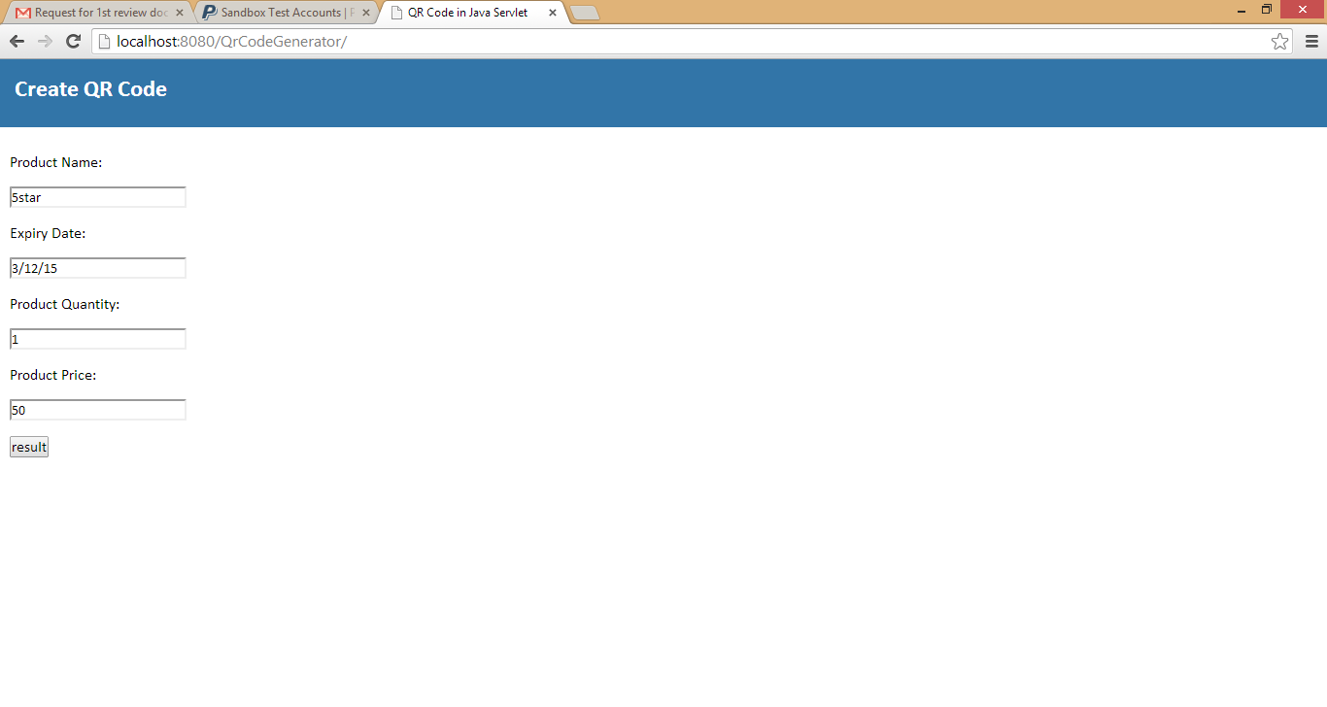

38

It shows how the QR code has been generated using the product descriptions.

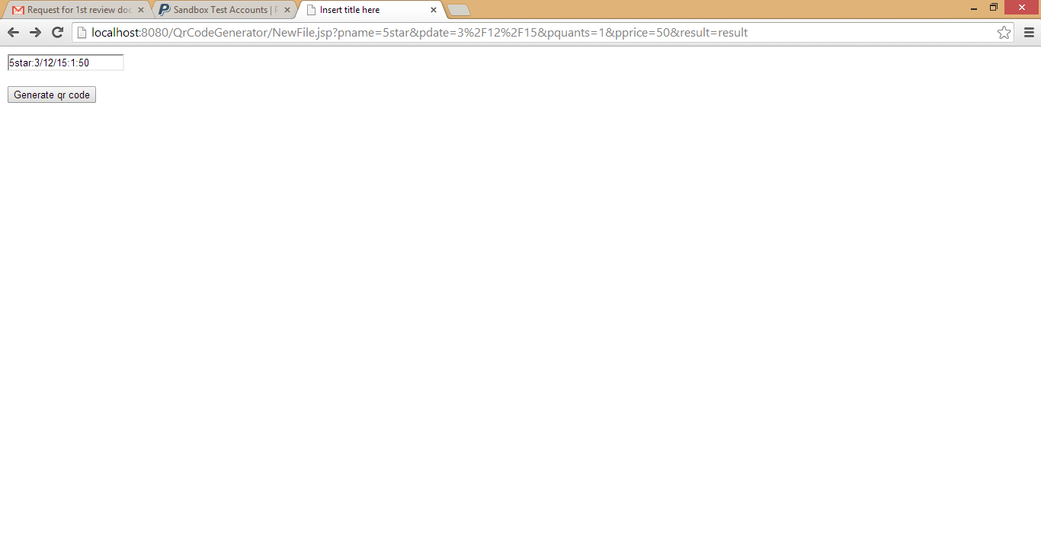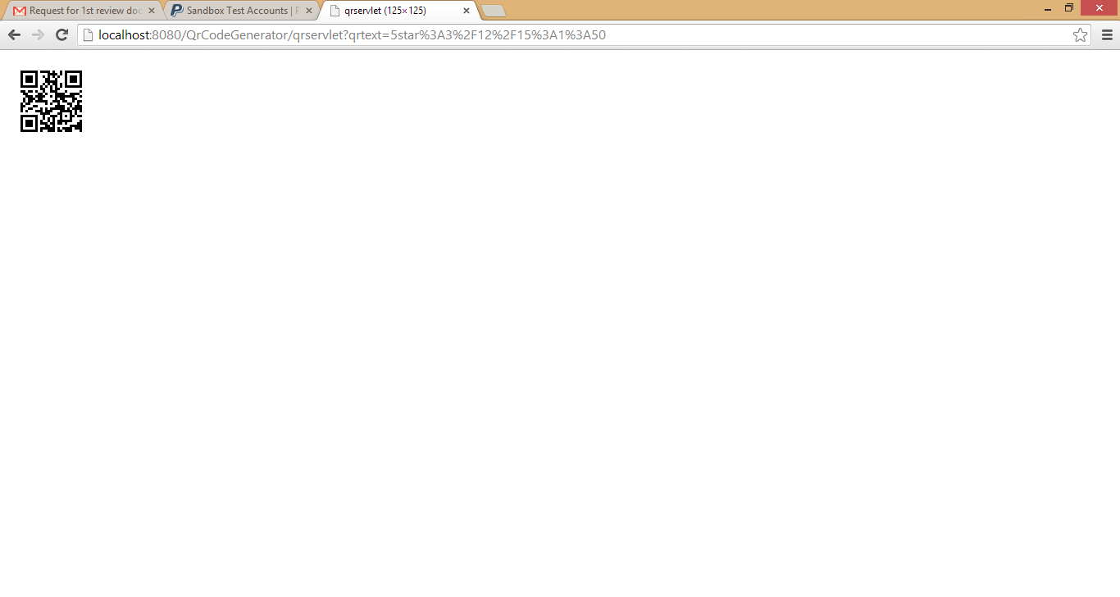

39

**OWNER PAGE**

The login page of the owner.

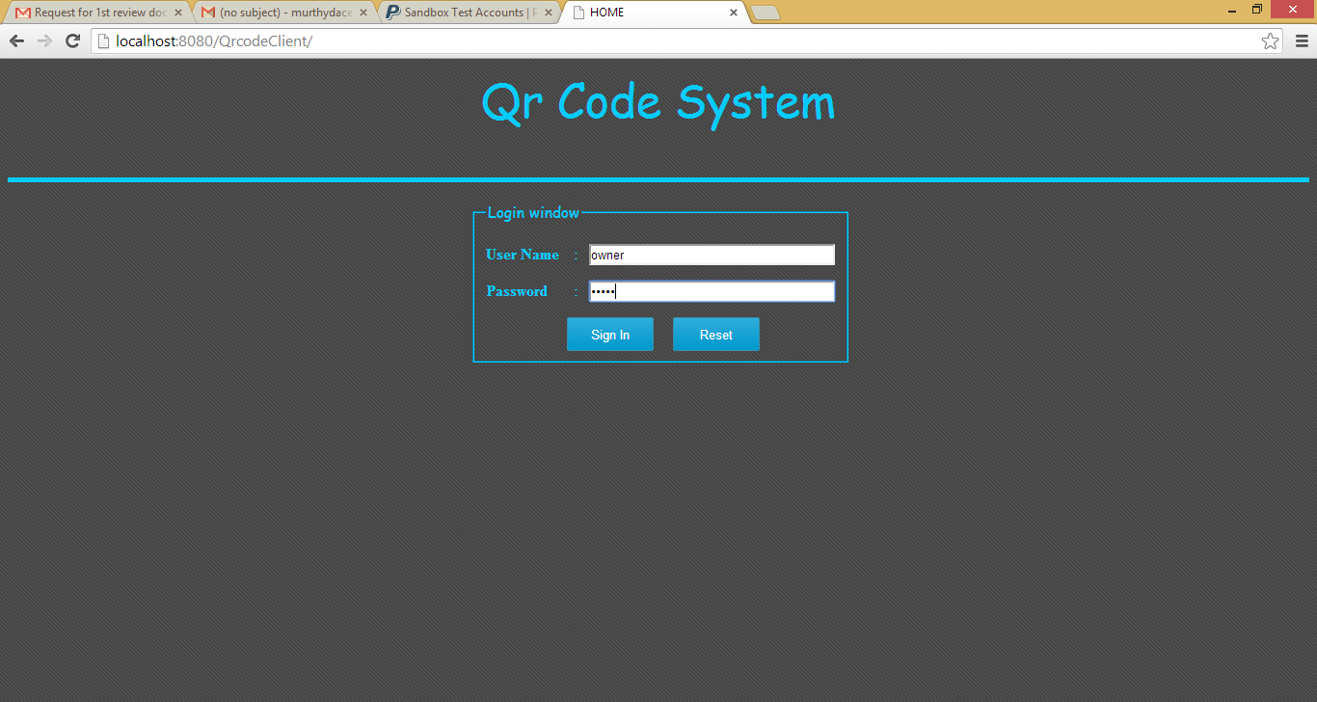

Viewing the details about the product.

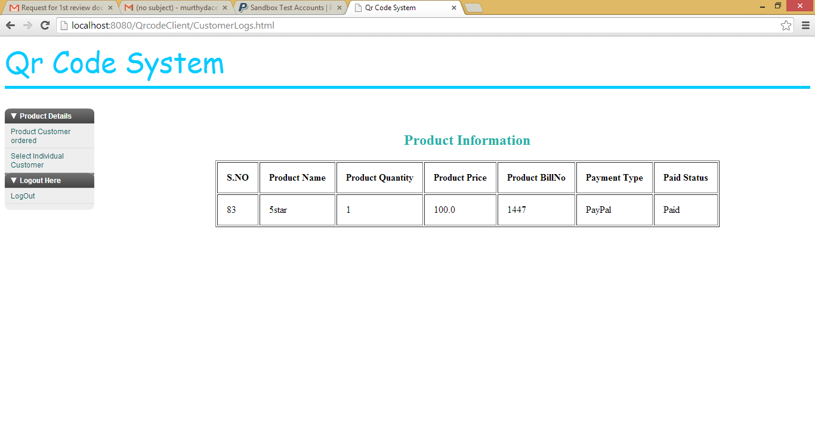

40

Getting the detail about individual customer using bill number.

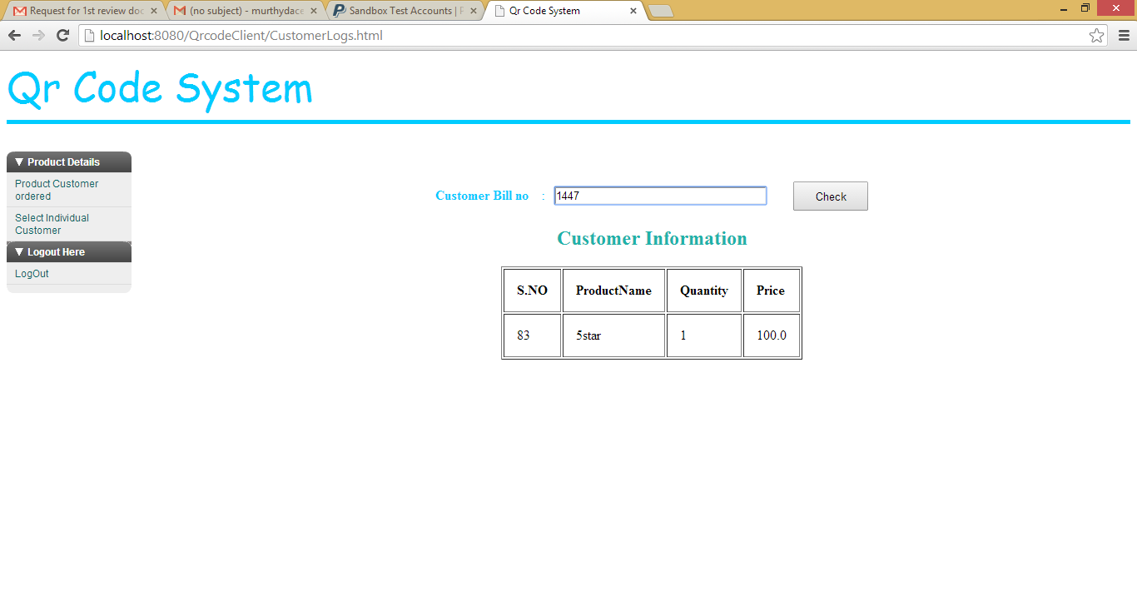

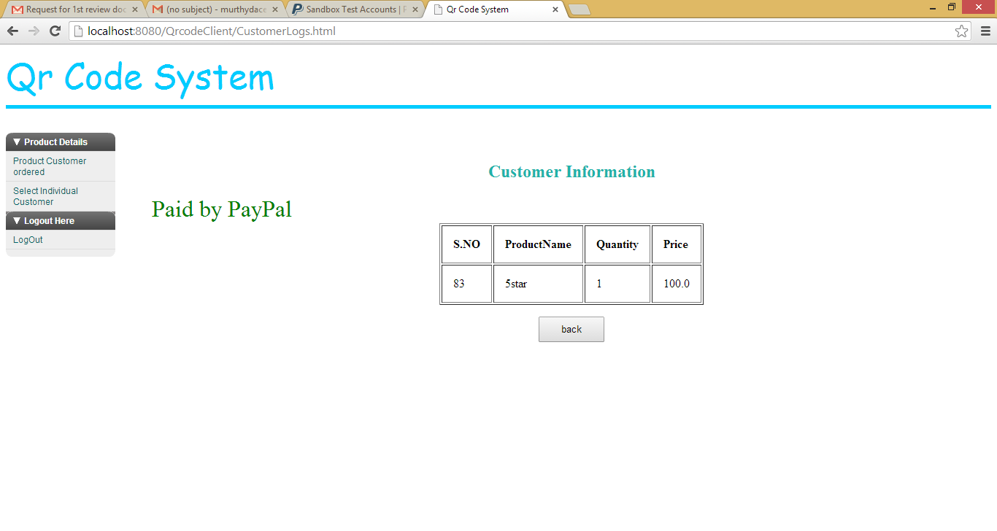

41

**CUSTOMER MOBILE MODULE**

User login page

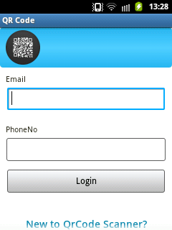

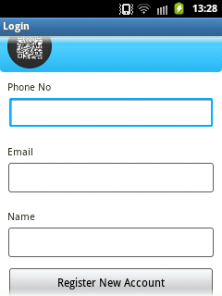

42

The scanning page of the QR code reader.

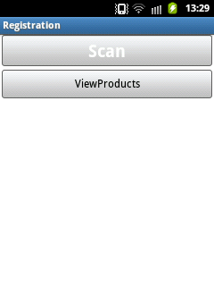

The focus of the scan.

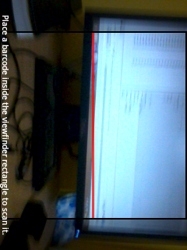

43

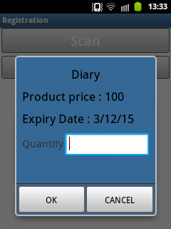

Customer topay the amount using by direct payment or pay pal method.

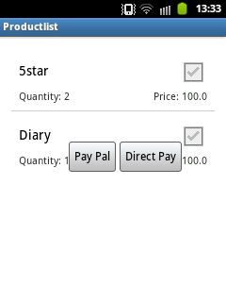

44

Pay pal account login page.

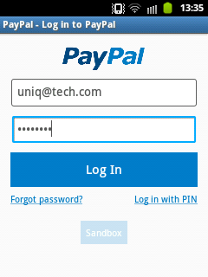

Sending payment using pay pal account.



45

**REFERENCES**

**CHAPTER 11**

**REFERENCES**

[1] Xiong Zou, Guo-dong Liu, Jian-min Wang, “Study on the Sequence of Steps in the QR Code Image Preprocessing,” 2nd International Conference on Future Computer and Communication, 2010.

[2] R.C. Gonzalez and R.E. Woods, Digital Image Processing, Prentice Hall, Inc., U.S.A., 2002.

[3] Yue Liu, Ju Yang, Mingjun Liu, “Recognition of QR Code with Mobile Phones,” Chinese Control and Decision Conference, 2008, pp. 204

[4] “Denso wave incorporated,” <http://www.denso-wave.com/qrcode/index-e.html>.

[5] S. Pholsomboon and S. Vongpradhip, “Rotation, scale, and translation resilient digital watermarking based on complex exponential function”.

[6] Mahasak Ketcham and Sartid Vongprahip, “An Algorithm for Intelligent AudioWatermarking Using Genetic Algorithm”.

[7] Mahasak Ketcham and Sartid Vongpradhip, “Genetic Algorithm Audio

Watermarking using Multiple Image-based Watermarks.

[8] M. Ketcham, and S. Vongpradhip, “Intelligent Audio Watermarking

using Genetic Algorithm in DWT Domain.

46